**Idea Wrapper**

**IDEA WRAPPER**

A project report submitted for the partial fulfillment for the award of degree of

**MASTER OF COMPUTER SCIENCE**

Submitted By

**R . Priya Dharshini**

(Reg. no:1913102078119)

Under The Guidence Of

**M. Kalaivani , MCA., M.Phil., SET,**

Assistant Professor,

PG Department of Computer Science



**DWARAKA DOSS GOVERDHAN DOSS VAISHNAV COLLEGE (AUTONOMOUS)**

**ARUMBAKKAM, CHENNAI-600106**

**DWARAKA DOSS GOVERDHAN DOSS VAISHNAV COLLEGE**

**(AUTONOMOUS)**

**ARUMBAKKAM, CHENNAI - 600106**

**PG DEPARTMENT OF COMPUTER SCIENCE**



**BONAFIDE CERTIFICATE**

This is to certify that this project work entitled “**IDEA WRAPPER**” is a bonafide record done by **PRIYA DHARSHINI R** (**Reg.No**:**1913102078119**) in partial fulfilment for award of degree of **Master of Science (Computer Science)** under our guidance and supervision, during the academic year 2020 - 2021.

**Project Guide Head of the Department**

Submitted For The Viva – Voice Examination Held On ………….…………… At

Dwaraka Doss Goverdhan Doss Vaishnav College, Chennai- 600 106.

**Internal Examiner External Examiner**

**ACKNOWLEDGEMENT**

I take this opportunity to express my sincere thanks to everyone in guiding me to complete this project. I thank the almighty for the blessings that have been showered upon me to complete the project successfully.

I express my sincere thanks to **Principal Dr. S. SANTHOSH BABOO, M.Sc, Ph.D., Dwaraka Doss Goverdhan Doss Vaishnav College** for his help and valuable guidelines for the successful completion of this project.

My sincere thanks to the Head, PG Department of Computer Science, **Dr.T.Santhanam, M.Sc., Ph.D., PGDCA** for his continued support and his help in compiling the project.

I acknowledge my gratitude to my guide **M. KALAIVANI , MCA., M.Phil., SET,**for providing me an opportunity to do my project work on **IDEA WRAPPER.**

My special thanks to all faculty members and staff members of PG Department of Computer Science and Application for their support and encouragement for the successful completion of the project.

I also thank my friends for providing moral support and timely help to finish the project.

I whole heartedly express my sincere thanks to my lovable parents and relatives who encouraged me with moral and economic support.

**ABSTRACT**

Develop an online web community for User’s to post their idea without having a need to install any software**.** Software as a service is a model of software deployment where an application is hosted as a service provided to customers across the Internet. By eliminating the need to install and run the application on the customer's own computer, SaaS alleviates the customer's burden of software maintenance, ongoing operation, and support. Anyone can have idea for an application but may not know how to implement or find a solution for it. To satisfy this need we came up with the application called **Idea Wrapper**

**Idea Wrapper** is an online web community for user’s to post their idea’s and helps to find a solution. The application is to help user’s to find a solution and to get one or more Mvp for their idea.the Solution or mvp will be posted by developer’s who are interested in their idea. Based on category user can search idea’s to explore .The prime goal of this application is to get solution for one’s idea. This application has role based access. Admin has to Authorize user to access privileges. Only Verified user can post idea’s. Post is associated with upvote, downvote,comments,replys and solutions .This will help user to analize whether his/her idea has an good impact with developers or other user’s.

**INDEX**

|  |  |  |
| --- | --- | --- |
| **S.NO** | **TITLE** | **PAGE NO** |
| **1** | **INTRODUCTION** |  |
| 1.1 ORGANIZATION PROFILE | 1 |
| 1.2 EXISTING SYSTEM | 15 |
| 1.3 PROPOSED SYSTEM | 15 |
| 1.4 FUNCTIONAL DESCRIPTION | 15 |
| 1.5 HARDWARE AND SOFTWARE REQUIREMENTS | 16 |
| **2** | **SYSTEMANALYSIS** |  |
| 2.1 USE CASE DIAGRAM | 18 |
| 2.3 SEQUENCE DIAGRAM | 29 |
| **3** | **SYSTEM DESIGN** |  |
| 3.1 CLASS DIAGRAM | 30 |
| 3.2 TABLE DESIGN | 31 |
| 3.3 MODULE DESCRIPTION | 32 |
| **4** | **SYSTEM IMPLEMENTATION** |  |
| 4.1 SOFTWARE DESCRIPTION | 33 |
| **5** | **SYSTEM TESTING** |  |
| 5.1 UNIT TESTING | 36 |
| 5.2 INTEGRATION TESTING | 39 |
| 5.3 ACCEPTANCE TESTING |  |

**INDEX**

|  |  |  |
| --- | --- | --- |
| **S.NO** | **TITLE** | **PAGE**  **NO** |
| **6** | **CONCLUSION AND FUTURE ENHANCEMENTS** | 40 |
|  | **BIBILIOGRAPHY** |  |
| **APPENDIX** |
| A. SCREENSHOTS |
| B. SAMPLE CODE |

**CHAPTER 1**

**INTRODUCTION**

* 1. **Organization Profile**

MAANTT is an educational technology company creating cutting-edge technology solutions that make learning, outcome driven, and customized for skills and employability. Banyanpro is a product of MAANTT which is a cloud-based software application for Hiring and Personalized Learning. They offer general aptitude, Psychometric, IT competency (Programming or Database or Project based) to help you analyse the quality of your candidates'.

**Why use Banyanpro?**

Through its advanced technologies like automation and robotics, using simplified design thinking models and placing students first, Banyanpro brings in a new way to learn, practice & apply learning. Banyanpro has the necessary inbuilt tools that help everyone involved. Ranging from yourself, your students as well as the IT department, all users can access the portal with ease and convenience. Effective eLearning is what they promise.  
Here’s how they do that.

**COURSE MANAGEMENT**

* Multiple Content Types

Build custom courses by uploading videos or re-using presentations and documents. Curate courses by consuming contents from web-sources.

* Tin Can API (xAPI)

Tin Can API allows you to track the learning behavior of users. Curious to know how your employees are learning on Compliance Policy.

* Topic wise Assessments

Track individual learning behavior and verify their knowledge and skill on each topics and sub-topics.

* Learning Paths

Add structure to your training programs by ability to control both the order and the time-frame in which the courses become available to the learners.

* Learning Compliance

Complete control over the individuals or group learning progress and take corrective measures based on learning compliance report.

**LEARNING DELIVERY**

* Digital Certificates

Design your own certificates that are issued for qualified learners for predefined periods of time. You can use it for issuing certificate for completing compliance training or any technical training.

* Digital Badges

Get recognition for learning and then share it on social media like Facebook, LinkedIn or Twitter. A digital badgeis an online representation of a skill you've earned and it can't be duplicated.

* Blended Learning

Blend the online learning with traditional classroom methods by inviting learners through video conference.

* Flip Class Room Model

Reverse the traditional learning environment by delivering instructional content online and make classroom learning more dynamic and interactive environment.

* Gamifications

Bring learning to life with Badges and Leader boards. Motivate your employees to learn and earn points and compete with peers.

* Video Conferencing

Collaborate and learn with integrated video conference feature or customize based on your requirement.

**ASSESSMENT MANAGEMENT**

* Question Bank

A Library containing thousands of questions on a specific subject which will help to organize and prevent cheating.

* Blooms Taxonomy

Bloom’s taxonomy is a powerful tool to help your organization to develop powerful learning objectives.

* Competency and Sub Competency

Generate support for building competency models in your organization.

* Item Analysis

Assess the quality of each questions and it's options to improve the efficiency of your Assessments.

* Invite

Invite candidates to assessments by sending unique link and allow them to take assessments on their comfort anytime or anywhere.

* Web Proctoring

Ensure the authenticity of the test taker and prevent him/her from cheating by using advanced Web proctoring features.

* Discussion Forum

Employees can teach each other, clarify assumptions and improve collaboration.

* Randomization

Improve the Assessment quality by randomizing questions and answers.

**ENTERPRISE READY**

* Custom Roles or User Types

Limit employee's access to certain features via custom user types or Roles.

* High Security

Communication over secure protocol and enforcing various security mechanisms.

* Integrations

It's very simple to integrate Banyanpro with hundreds of other third-party web apps like Slack, GitHub etc.

* Single Sign On (SSO)

Banyanpro supports LDAP, SAML2 and Active directory to improve the user experience.

* Branching

Group your learning environment to branches and each group is like a separate department.

* API

An extensive list of Rest-API to communicate with other learning portal and get the data you need.

* GDPR Compliant

Comply with GDPR with features that let you respect users’ privacy to collect approval, exclude users who have opted out of data collection and allow users to self-delete.

**WHITE LABELLING**

* Highly Customizable

Choose your own domain customize your emails templates based on your organization needs.

* Themeable

Customize the look and feel of your portal by choosing color to match your organization.

* Make it yours

Add your logo and favicon, change the colors, and create branded sign in page.

**SYSTEM**

* Responsive

Access Banyanpro anywhere, anytime and by using any device.

* Multilingual

Banyanpro supports localization and internalization. You can configure your regional languages based on your leaner preference.

* Infrastructure

Azure cloud blazing fast servers, improve the speed of delivery and availability.

* Web Standards

Banyanpro built on top of the modern web standard and technologies.

In a nutshell Banyanpro is

##### **Easy to use**

Banyanpro is really easy to use. They built it to increase your satisfaction and fun from personalized learning.

##### **Reports and Analytics that make sense**

Simple and comprehensible reports and analytics which helps to take decisions easily.

##### **Scalable to any size**

Banyanpro is scalable to any enterprise size and easy integration with other existing Apps.

* **Highly Customizable**

Your own Banyanpro with custom domain, your logo and theme.

* **Supports Regional languages**

Make Banyanpro more personalized by switching on or off to any language.

##### **99.9% Availability**

Banyanpro is cloud based so no need to install, update or backup any software or hardware.

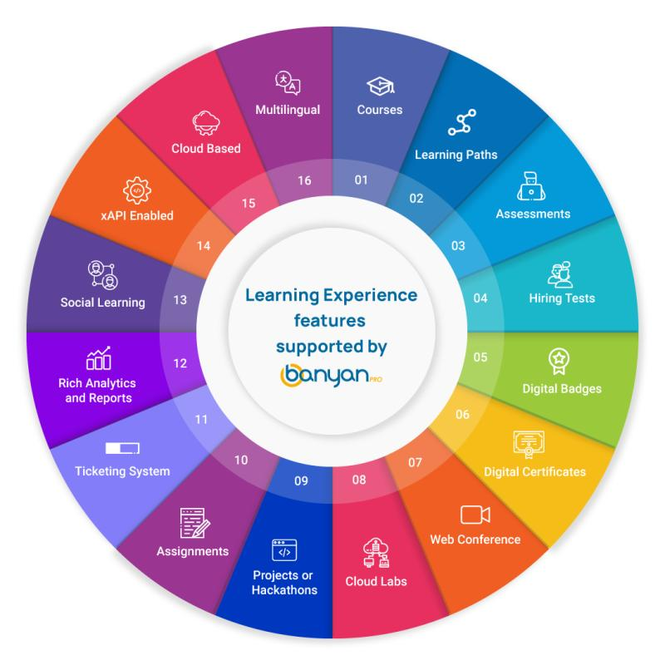

Banyanpro aims to solve today’s learning challenges across schools, colleges, universities, and organizations and enable students and workforce to prepare and perform at their very best in tomorrow ’s digital economy. Banyanpro offers the best Hiring and Learning solution for any industry. They have their feet firm in Healthcare, Aviation, Franchise, Call Centers, Automotive and Education.

Banyanpro can be used for,

**Digital Assessment for Hiring**

Assess your candidates’ skills and job fit with our proctored assessments. They offer General Aptitude, Psychometric, Software Programming and Database to help you analyze the quality of your candidates'​. Pick your assessments and hire the best fit.

CREATE YOUR ASSESSMENT -

Choose our predefined assessments for the skills you need or add individual questions from question bank to a new empty Assessment. You can also create your own custom question bank and add questions to build an assessment tailored to your needs.

INVITE CANDIDATES -

Save time by inviting all your candidates to an assessment through one simple user interface. Enter their email addresses or bulk upload, choose a deadline for an assessment, and hit the invite button.

CANDIDATES TAKE THE ASSESSMENT -

The Invited candidates will receive an email with a link to the online assessment. Candidates take the assessment from the comfort of their homes at their convenience. Secure your online exam with banyanpro.

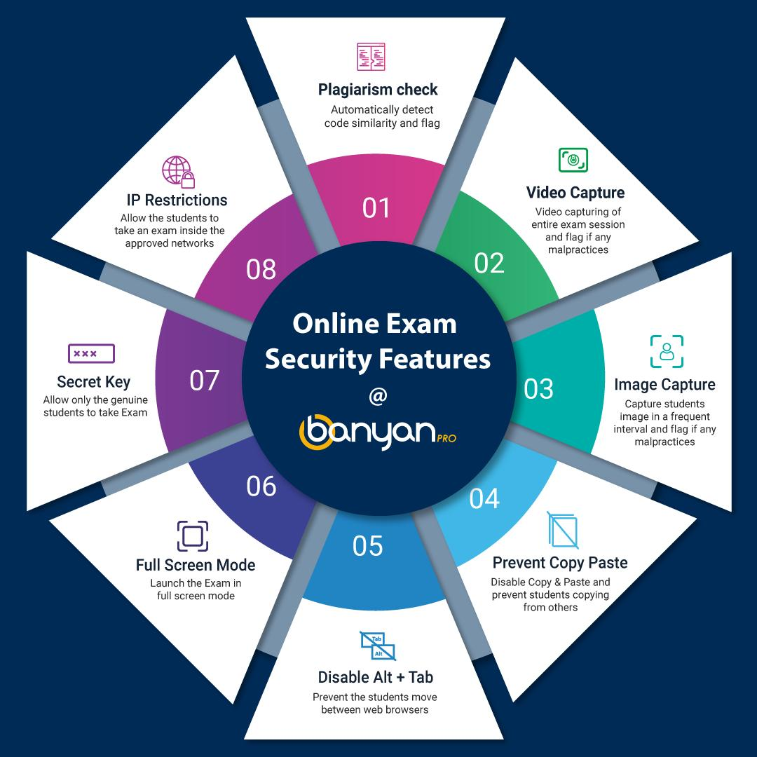

RANK AND HIRE TOP TALENT -

All candidates will be sorted and graded into PASS or FAIL . They also provide a feature to filter the candidates on various parameters and notify candidates by sending them pass or fail emails. You can download and use the assessment report to ask the candidate for more details during an interview.

**ASSESSMENT TYPES**

General Aptitude Test -

Assess candidates on Verbal, Non-Verbal, Logical, and IQ for multiple roles to ascertain their analytical and problem-solving skills.

Programming -

Conduct online programming challenges on C, C++, JAVA, C#, Python, JavaScript and PHP. Banyanpro supports 13 different programming languages to evaluate candidates hands-on Technical, Logical and Problem-Solving skills.

Psychometric Test -

Evaluate candidate’s psychological compatibility with eliminating deficiencies in a face-to-face interview process. Banyanpro supports Big-5 and RIASEC personality Tests.

Real project Based -

Evaluate candidates with Real projects which includes different layers, Front end, Business Logic and Database programming. Banyanpro supports assessments for .NET Full stack, Java Full Stack and MEAN Stack.

**Personalized Learning**

Every human is unique, need special care to provide learning experiences for reaching individual achievements.

## WHY PERSONALIZED LEARNING?

When you need customized learning for each individual's strengths, needs, skills and interests. Each individual gets a learning path based on what they know and how they learn best. You can also use Banyanpro when you need digital assessment for hiring to assess your candidate’s skills and job fit with their proctored assessments.

Power to Author

* Design and Deliver courses with flexible learning design
* Tools for monitoring learner behaviour to influence learning effectiveness
* Design classes encouraging ‘doing’

Learner Centric

* Learn by doing
* Encourage peer learning using collaboration power
* Improve learning engagement using Gamification elements
* Mobile friendly

Best in class Operation

* 24/7 support
* Helps you reach a mass audience
* Good customization features

**FEATURES**

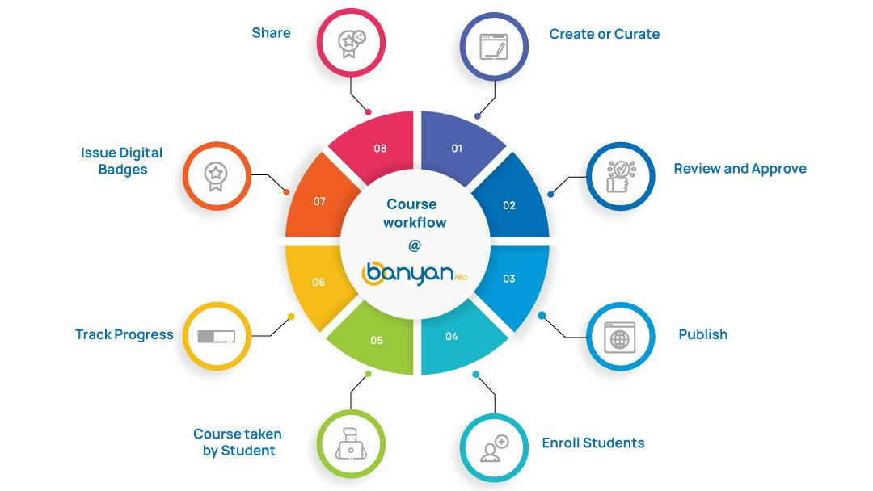

* Create or Curate courses -

Create courses from Video, Audio, PDF, and Documents. Curate course from any multimedia elements like YouTube and Web Pages.

* Learning Paths -

Select the courses which you want to tied together for learners to progress through, mastering a particular subject.

* Topic wise Assessments -

Assessments make it easy to ensure that the critical knowledge is properly delivered.

* Blended Learning -

Combine e-learning with instructor led training to deliver courses.

* Design and issue Custom Certifications -

Design and issue certificates based on your need.

* Learner Progress -

Track individual learners or group of learners learning compliance.

* Design your theme -

Enhance your brand by building a theme that conveys your own company personality and style. Banyanpro lets you choose your theme by using a user-friendly interface.

**LEARNING TYPES**

BanyanPro offers the best Learning solution for any industry.

* Bundle of Courses -

Starting learning for free with a wide range of free online courses covering different subjects.

* Learning Paths -

Boost your skills. Stay sharp. Get ahead. A structured training programme of your choosing, and dramatically reduce your time to learning proficiency.

* Cloud Labs -

Real cloud environments that help developers and IT professionals. Self-paced labs that provide hands-on practice with Cloud technologies in a live environment.

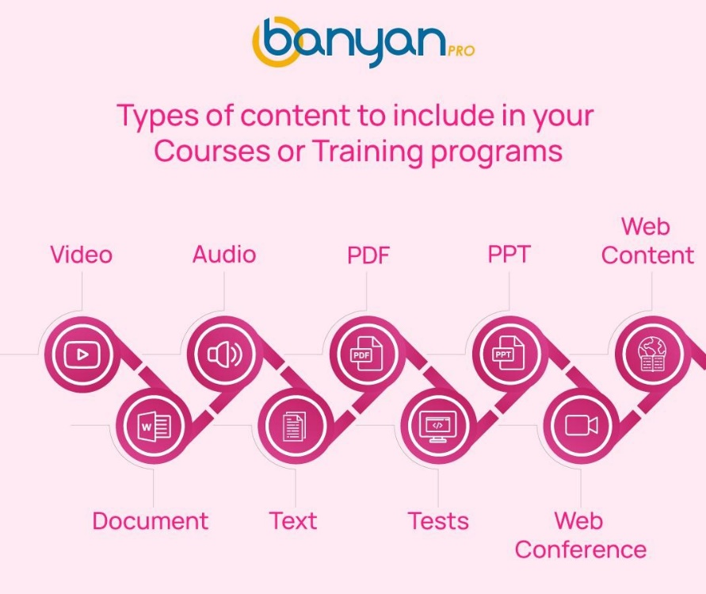

**TECHNOLOGIES**

BanyanPro enables teams to assess candidates on the technologies listed below, with ease.

#### **PROGRAMMING LANGUAGES**

### C

General-purpose, imperative computer programming language.

### C++

Imperative, object-oriented and generic programming language.

### C#

A simple, modern, general-purpose, object-oriented programming language by Microsoft.

### PYTHON

General-purpose, high-level programming language.

### JAVA

General-purpose, concurrent, class-based programming language.

### PASCAL

Small, efficient language using structured programming and data structuring.

### R

Statistical computing and graphics programming language.

### PERL

Family of high-level, interpreted, dynamic programming languages.

### JAVASCRIPT

Scripting language of the Web.

### JQUERY

jQuery is a JavaScript library designed to simplify HTML DOM tree traversal and manipulation.

### SHELL

Computer program designed to be run by the Unix shell.

### INFORMATICA

Data integration/ETL tool.

### NODEJS

A cross-platform runtime environment for developing server-side web applications.

### REACT

A JavaScript library to build user interfaces.

### SELENIUM

Used for test automation only web applications.

### UFT

HP Unified Functional Testing (UFT) / QTP.

#### **DATABASES**

### ANSI SQL

Structured Programming Languagefor storing, manipulating and retrieving data in databases.

### ORACLE

All Content · Database · Fusion Middleware · Enterprise Manager

### MYSQL

RDBMS being used for developing various web-based software applications.

### MS SQL SERVER

ORDBMS, platform dependent, both GUI and command-based software.

### MONGODB

Database and leading NoSQL database. MongoDB is written in C++.

#### **APPLICATION FRAMEWORKS**

### HTML5

HTML5 is the latest and most enhanced version of HTML.

### CSS3

CSS3 is a latest standard of css earlier versions(CSS2).

### ANGULAR

Super heroic JavaScript MVW framework.

To keep pace with ever-changing business demands Banyanpro uses Cloud Labs

**HOW IT WORKS?**

CHOOSE CLOUD LAB FROM LIBRARY -

Banyanpro supports more than 50 technology labs, guided exercises and hands-on. Choose the cloud lab and fly.

INVITE CANDIDATES -

Save time by inviting all your candidates to a assessment through one simple user Invite or enrol the learners and assign chosen cloud lab.

TRACK THEIR PROGRESS -

You can track their progress and provide timely feedback for improvements.

DRIVE BUSINESS OUTCOME -

Measure individual progress and drive business outcome.

### **WHY CLOUD LABS ?**

* Launch cloud labs in minute

Choose the lab and its configuration and launch it.

* Scalable

Scalable to any enterprise size and easy integration with other Apps.

* Total cost savings

Pay as you go. No need to spend on infrastructure hence total cost savings.

* Fully secured

Secure cloud environment with best in class infrastructure.

**FEATURES**

* 50+ technology labs
* Rich reports and analytics
* On-demand
* No installation and no compatibility issue
* 24X7 Support
* Real production environment
* Pay as you go
* Seamless integration

**MANY WAYS TO USE BANYANPRO**

* CLOUD LABS FOR ENTERPRISES -

Upskill or Reskill your employees on the latest technologies with Banyanpro cloud labs.

* CLOUD LABS FOR EDUCATIONAL INSTITUTIONS -

Make your students industry ready by providing Banyanpro cloud labs on latest technology stacks.

* CLOUD LABS FOR LEARNING PROVIDERS -

Enable students by providing hands-on experience with Banyanpro cloud labs.

**1.2 EXISTING SYSTEM**

In the existing system the Developers who have many idea’s may not know where to share and to get solution for their idea. This may cause lack in enhancing the idea’s or sometime it may consume more time to find a solution . There is no particular web community for developers to share idea’s.

**1.3 PROPOSED SYSTEM**

User need a web community where they can post their idea’s and can find the solution. This helps the users to to find one or more mvp for a idea. To satisfy this need we came up with this web community called **IdeaWrapper**

**Idea Wrapper** is an online web community for user’s to post their idea’s and helps to find a solution. The application is to help user’s to find a solution and to get one or more Mvp for their idea.the Solution or mvp will be posted by developer’s who are interested in their idea. Based on category user can search idea’s to explore .The prime goal of this application is to get solution for one’s idea. This application has role based access. Admin has to Authorize user to access privileges. Verfied user’s profile is store with a verification flag.

Only Verified user can post idea .Post is associated with upvote, downvote,comments,replys and solutions .This will help user to analyze whether his/her idea has an good impact with developers or other user’s.Solution(MVP) is posted by developer’s who is interested in that particular idea.Mvp is uploaded in .Zip format and associated with upvote, downvote,comments and reply.

**1.4 FUNCTIONAL DESCRIPTION**

* Registration is offered. Then a registered user logs into our web application
* Based on their role they will be redirected to home page or admin page
* User’s can update their profile ,view all idea’s and request for verification badge .
* verified users can post, update, delete their idea’s, and can upvote,downvote ,comment ,report and produce mvp for other idea’s
* Admin can verify or delete a verification request and can handle reported post from users

**1.4.1Work Area**

* **JavaScript -** JavaScript, often abbreviated as JS, is a programming language that conforms to the ECMAScript specification. JavaScript is high-level, often just-in-time compiled, and multi-paradigm. It has curly-bracket syntax, dynamic typing, prototype-based object-orientation, and first-class functions.
* **React js -** React is an open-source front-end JavaScript library for building user interfaces or UI components. It is maintained by Facebook and a community of individual developers and companies. React can be used as a base in the development of single-page or mobile applications..
* **MongoDb -** MongoDB is an open source NoSQL database management program. NoSQL is used as an alternative to traditional relational databases. ... MongoDB is a tool that can manage document-oriented information, store or retrieve information.
* **NodeJS -** Node.js is an open-source, cross-platform, JavaScript runtime environment that executes JavaScript code outside a web browser.
* **Express js -** It's a web framework that let's you structure a web application to handle multiple different http requests at a specific url. Express is a minimal, open source and flexible Node. js web app framework designed to make developing websites, web apps, & API's much easier**.**

**1.4.2Aim of the project**

* Producing Mvp for user’s idea
* To Explore more idea’s

**1.4.3Key features and scope of the project**

* Posting idea’s
* producing Mvp
* Posting Comments and reply’s
* Adding upVote and DownVote to post,comments,replys and solution
* Responsive design

**1.5 HARDWARE AND SOFTWARE REQUIREMENTS**

1. Necessary resources – 1 Pc
2. Number of developers – 1
3. Required skills
   1. Knowledge about HTML, CSS, JavaScript, ReactJs, Mongoose, NodeJS and Express
   2. Microsoft Visual Studio code IDE
   3. MongoAtlas
   4. Networking protocols
4. Hardware requirements:
   1. Intel® Pentium® or AMD processor, 2 GHz with MMX or equivalent
   2. 4 GB RAM
   3. 10 GB available hard disk space
5. Environment and development tools required for the development process
   1. Microsoft windows 7 or higher
   2. Microsoft Visual Studio Code IDE
   3. PostMan

**1.5.1 Technology Used**

* RESTful Webservice
* JWT(JSON Web Token)
* Git

**1.5.2 Libraries Used**

* Express js
* Mongoose
* Nodemon
* Material ui

**1.5.3 Data Formats**

Data at server side: JSON

When user selects to store details entered on client side (i.e. on DB) then the data is saved in string format.

**CHAPTER 2**

**SYSTEM ANALYSIS**

**2.1 SOFTWARE REQUIREMENT SPECIFICATION:**

* Front end : Reactjs,css,javascript,html
* Back end :Nodejs ,Expressjs
* Database:MongoDB

**2.2 USE CASES**

**2.2.1 Use cases for a User:**

|  |  |
| --- | --- |
| **Use Case U1** | Sign up |
| **Actor** | User |
| **Basic Flow** | Sign up to create a new profile by entering all the mandatory details. On successful signup the user receives a confirmation alert and redirected to the Home page. |
| **Exception Flow** | On unsuccessful signup user receives an error alert. |

|  |  |
| --- | --- |
| **Use Case U2** | Login |
| **Actor** | User |
| **Basic Flow** | Login with valid credentials to access the application. |
| **Exception Flow** | On unsuccessful login user receives an error alert. |

|  |  |
| --- | --- |
| **Use Case U3** | Edit profile |
| **Actor** | User |
| **Basic Flow** | Update user profile and save. |

|  |  |
| --- | --- |
| **Use Case U4** | Add Post |
| **Actor** | User |
| **Basic Flow** | Add Post . |

|  |  |
| --- | --- |
| **Use Case U5** | Edit Post |
| **Actor** | User |
| **Basic Flow** | Click on edit to update a Post. |

|  |  |
| --- | --- |
| **Use Case U6** | Delete Post |
| **Actor** | User |
| **Basic Flow** | Click on delete to remove a Post. |

|  |  |
| --- | --- |
| **Use Case U7** | Add upVote and downVote for post |
| **Actor** | User |
| **Basic Flow** | Add upVote and DownVote for post |

|  |  |
| --- | --- |
| **Use Case U8** | Add comment for post |
| **Actor** | User |
| **Basic Flow** | Add comments for Post |

|  |  |
| --- | --- |
| **Use Case U9** | Delete comments in post |
| **Actor** | User |
| **Basic Flow** | Delete comments in post |

|  |  |
| --- | --- |
| **Use Case U10** | Add reply for post’s comments |
| **Actor** | User |
| **Basic Flow** | Add reply for post’s comments |

|  |  |
| --- | --- |
| **Use Case U11** | Delete reply in post’s Comments |
| **Actor** | User |
| **Basic Flow** | Delete reply in post’s Comments |

|  |  |
| --- | --- |
| **Use Case U12** | Add upVote and DownVote for Posts comments |
| **Actor** | User |
| **Basic Flow** | Add upVote and DownVote for Posts comments |

|  |  |
| --- | --- |
| **Use Case U13** | Add upVote and DownVote for Post reply |
| **Actor** | User |
| **Basic Flow** | Add upVote and DownVote for Post reply |

|  |  |
| --- | --- |
| **Use Case U14** | Add mvp for post |
| **Actor** | User |
| **Basic Flow** | Add mvp for post |

|  |  |
| --- | --- |
| **Use Case U15** | Request verification |
| **Actor** | User |
| **Basic Flow** | Request verification by clicking on the profile dropdown menu -> Request Verification button |

|  |  |
| --- | --- |
| **Use Case U16** | View Idea’s |
| **Actor** | User |
| **Basic Flow** | View Post top post in home page by clicking the post user can view complete detailed post. |

|  |  |
| --- | --- |
| **Use Case U17** | Edit Mvp for the post |
| **Actor** | User |
| **Basic Flow** | Edit Mvp for the post |

|  |  |
| --- | --- |
| **Use Case U18** | Search post by category |
| **Actor** | User |
| **Basic Flow** | Search post by category from search bar. |

|  |  |
| --- | --- |
| **Use Case U19** | Delete mvp from post |
| **Actor** | User |
| **Basic Flow** | Click on Delete to remove mvp from post |

|  |  |
| --- | --- |
| **Use Case U20** | Add upvote and downvotes for mvp |
| **Actor** | User |
| **Basic Flow** | Add upvote and downvotes for mvp |

|  |  |
| --- | --- |
| **Use Case U21** | Add comments for mvp |
| **Actor** | User |
| **Basic Flow** | Add comments for mvp |

|  |  |
| --- | --- |
| **Use Case U22** | Delete comments from mvp |
| **Actor** | User |
| **Basic Flow** | Click delete to remove comments from mvp |

|  |  |
| --- | --- |
| **Use Case U23** | Add upvote and downvotes for comments mvp |
| **Actor** | User |
| **Basic Flow** | Add upvote and downvotes for comments mvp |

|  |  |
| --- | --- |
| **Use Case U24** | Add reply for comments mvp |
| **Actor** | User |
| **Basic Flow** | Add reply for comments mvp |

|  |  |
| --- | --- |
| **Use Case U25** | Add upvotes and downvotes for reply |
| **Actor** | User |
| **Basic Flow** | Add reply for comments mvp |

|  |  |
| --- | --- |
| **Use Case U26** | Delete reply from comments mvp |
| **Actor** | User |
| **Basic Flow** | Click on delet to remove reply |

|  |  |
| --- | --- |
| **Use Case U28** | Report a post |
| **Actor** | User |
| **Basic Flow** | User can report a irrelevant post by clicking on report |

|  |  |
| --- | --- |
| **Use Case U29** | Logout |
| **Actor** | User |
| **Basic Flow** | Logout from the application by clicking on Logout button from the profile dropdown icon. |

**2.2.3 Use cases for Admin:**

|  |  |
| --- | --- |
| **Use Case A1** | Login |
| **Actor** | Admin |
| **Basic Flow** | Login with valid credentials to access the tool. |
| **Exception Flow** | On unsuccessful login Admin receives an error alert. |

|  |  |
| --- | --- |
| **Use Case A2** | View requests for verification |
| **Actor** | Admin |
| **Basic Flow** | View all the requests for verification. |

|  |  |
| --- | --- |
| **Use Case A3** | Action on requests |
| **Actor** | Admin |
| **Basic Flow** | Grant verification for a user by clicking verify button or delete verification request by clicking on delete button. |

|  |  |
| --- | --- |
| **Use Case A4** | View reported posts |
| **Actor** | Admin |
| **Basic Flow** | View all the reported posts. |

|  |  |
| --- | --- |
| **Use Case A5** | Action on reported posts |
| **Actor** | Admin |
| **Basic Flow** | Checks the post is irrelevant if irrelevant removes post from db else removes the report request |

|  |  |
| --- | --- |
| **Use Case A6** | Logout |
| **Actor** | Admin |
| **Basic Flow** | Logout from the tool by clicking on Logout button from the profile dropdown icon. |

**2.3 SEQUENCE DIAGRAM**

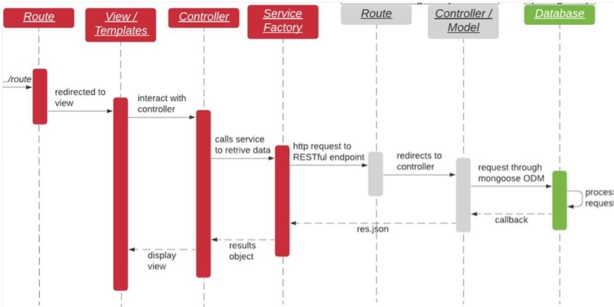

**CHAPTER 3**

**SYSTEM DESIGN**

**3.1CLASS DIAGRAM**

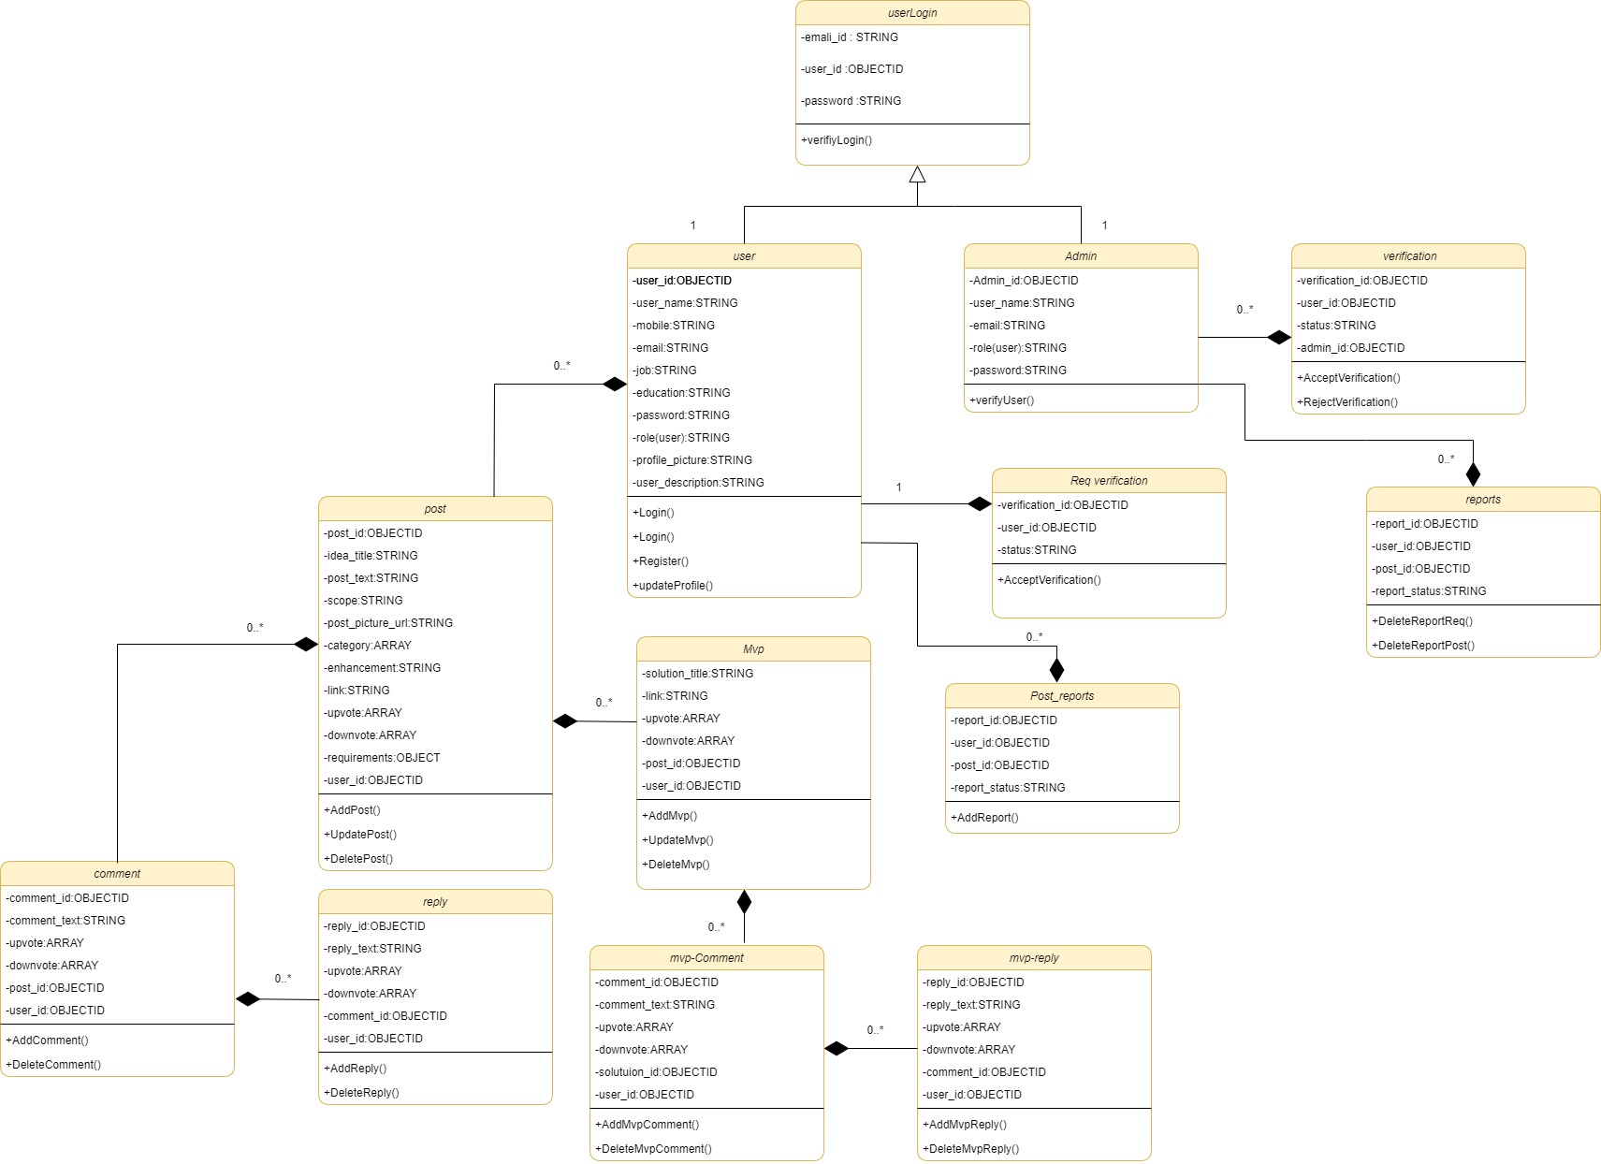

**3.2 TABLE DESIGN**

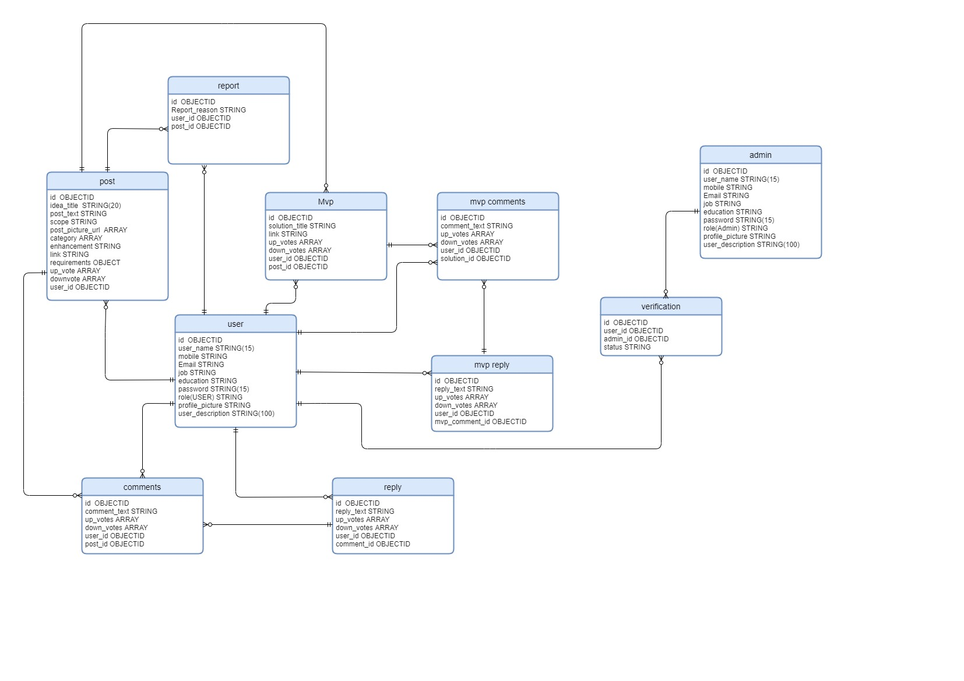

**3.3 MODULE DESCRIPTION**

1. Post
2. Profile
3. Mvp
4. Authorization

**Post**

Manage posts in the community with upvote,downvote,comments and upload prototype features. Managing content types with category

**Profile**

The profile module represents the information of the user where they can store their user information and it can also have a verification flag to identify their profile status. This acts as a dashboard for the user and may have other smaller modules which serves their purpose.

**Mvp**

Associates posts with multiple one or more solution and create insigts on responses

**Authorization**

Control access to features based on user privileges. Based on their privilege’s users can access certain features. Only the authorized users can access those features.

**CHAPTER 4**

**SYSTEM IMPLEMENTATION**

**4.1 SOFTWARE DESCRIPTION**

**VISUAL STUDIO CODE:**

Visual Studio Code is a source-code editor that can be used with a variety of programming languages, including Java, JavaScript, Go, Node.js and C++.It is based on the Electron framework, which is used to develop Node.js web apps that run on the Blink layout engine. Visual Studio Code employs the same editor component (codenamed "Monaco") used in Azure DevOps (formerly called Visual Studio Online and Visual Studio Team Services).

Visual Studio Code can be extended via extensions, available through a central repository. This includes additions to the editorand language support. A notable feature is the ability to create extensions that add support for new languages, themes, and debuggers, perform static code analysis, and add code linters using the Language Server Protocol.

Visual Studio Code includes multiple extensions for FTP, allowing the software to be used as a free alternative for web development. Code can be synced between the editor and the server, without downloading any extra software.

Visual Studio Code allows users to set the code page in which the active document is saved, the newline character, and the programming language of the active document. This allows it to be used on any platform, in any locale, and for any given programming language.

**NAVIGATION STRUCTURE**

* Candidate login
* Home
  + view weekly top post
    - view detailed post
    - view all weekly top posts
  + view recent 3 posts
    - view detailed post
    - view all posts
* profile
  + view profile page
  + view all post of that particular user
* Admin login
  + Admin page to take action on all verification requests and reports

**WEB APPLICATION FEATURES**

* Create user account
* User login
* Update profile and able to add and update user information
* Request verification and get your profile a verified badge to post content ,upvote,downvote,comment ,replys and solution.
* View all posts and solution
* Search posts by category
* View post detail
* View other user profile page
* Add,update or delete posts and solution
* Add or delete comments and replys
* Add upvotes and downvotes
* Can report other post
* User logout
* Admin login
* Accept verification request or delete a request
* Remove reported post or reject reports
* Admin logout

**PRODUCT FEATURES**

* Application installation is not required; users access the application on the web
* Updates and upgrades to newer versions are automatic
* Any computer with an Internet connection can become an access point to an application, no matter what operating system is installed.
* The risk of viral infection is greatly decreased when running an application on the web instead of an executable.

**CHAPTER 5**

**SYSTEMTESTING**

Testing is the process of executing a program or system with the intent of finding errors. Or, it involves any activity aimed at evaluating an attribute or capability of a program or system and determining that it meets its required results. Software is not unlike other physical processes where inputs are received, and outputs are produced. Where software differs is in the way it fails. Most physical systems fail in a fixed (and reasonably small) set of ways. By contrast, software can fail in many bizarre ways. Detecting all the different failure modes for software is generally infeasible.

Testing is one of the most important stages in software development which can prove whether the implementation and the requirements are in fidelity with each other. Testing can also confirm if the software specifications are complete and consistent. One of the main goals of testing is to have a minimum number of test cases that will find most implementation errors. The software/system that is been tested out here is known as OBSE (Objective Business Specification Environment). This is a process wherein the queries submitted online are evaluated by a group of experts.

**5.1 UNIT TESTNG:**

Unit testing is a software development process in which the smallest testable parts of an application, called units, are individually and independently scrutinized for proper operation. Unit testing involves only those characteristics that are vital to the performance of the unit under test. The units in a system are the modules and routines that are assembled and integrated to perform a specific function. In a large system, many modules at various levels are needed. Unit testing focuses on the modules, independently of one another, to locate errors.

Unit testing can be time-consuming and tedious. It demands patience and thoroughness on the part of the development team. Rigorous documentation must be maintained. Unit testing must be done with an awareness that it may not be possible to test a unit for every input scenario that will occur when the program is run in a real-world environment.

Some of the unit testing that compiles to the OBSE are:

Feeding the system with all combinations of data should test all the calculations. For valid data, programs should respond in the positive way and for invalid data programs are to be created such that it catches the errors and shows the user.

The contact no: consists of ten digits including the special characters, so during testing one should ensure that the programs do not accept anything other than the ten -digit code for the employee no.

Another e.g. for valid and invalid data check is that, in case ten-digit no is entered during the entry of transaction, and that number does not exist in the master file, or if the number entered is an exit case, then the programs should not allow the entry of such cases.

Thus, all conditions present in the program should be tested. Before proceeding, one must make sure that all the programs are working independently.

**5.1.1 IMPLEMENTATION OF UNIT TESTING:**

The usage of the unit testing could be seen registration form of the project clearly. The fields are tested in many cases and conditions.

* + If the fields are empty, the browser shows an alert message.
  + In fields like contact number if text is entered the browser shows an alert message. And there is also vice done for another field.

**TESTING TEST CASES**

|  |  |  |  |  |  |
| --- | --- | --- | --- | --- | --- |
| **Id** | **Scenario** | **Test Cases** | **Expected Result** | **Actual Result** | **Pass/Fail** |
| 1 | **Registration** | Enter null in mandatory fields. | It should not do the registration and show error. | It will show an error message. | Pass |
| Enter incorrect data | It should not do the registration and show error. | It will show an error message. | Pass |
| Enter correct data of all required field | It should let do the registration. | It will show the message of  successful registration. | Pass |
| 2 | **Login** | Enter null username or password. | It should not do the login and show error. | It will show an error message. | Pass |
| Enter wrong data of username or password. | It should not do the login show error. | It will show an error message. | Pass |
| Enter correct data of username or password. | It should let do login. | It will show the message of successfully login. | Pass |
| 3 | **Search Posts** | Enter null in mandatory fields. | It will not give any searched result. | It will not show any result. | Pass |
|  | **Search Post** | Enter correct data of all required field. | It should show the  appropriate post. | It will show the categorized post. | Pass |
| 4 | **Add a post** | Enter null in mandatory  Fields | It will add the post. | It will show the messages that enter the required details. | Pass |
| Enter correct data of all required field. | It should add the post. | It will add the job successfully. | Pass |
| 5 | **Add user information** | Enter null in mandatory  Fields | It will not give permission to add the information | It will show the messages that enter the required details. | Pass |
| Enter correct data of all required field. | It should add the information. | It will successfully add the information. | Pass |
| 6 | **Approve /**  **Delete the verification request** | Approve the applied verification request. | It should approve the user verification request. | It will approve the user verification request. | Pass |
| Delete the applied verification request. | It should delete the verification request. | It will delete the verification request. | Pass |

**5.2 INTEGRATION TESTING:**

Also known as Integration and Testing (I&T), is a software development process which program unit are combined and tested as groups in multiple ways. There are two major ways of carrying out an integration test, called the bottom-up method and the top-down method.

Bottom-up integration testing begins with unit testing, followed by tests of progressively higher-level combinations of units called modules or builds.

In top-down integration testing*,* the highest-level modules are tested first, and progressively lower-level modules are tested after that. In a comprehensive software development environment, bottom-up testing is usually done first, followed by top-down testing.

The process concludes with multiple tests of the complete application, preferably in scenarios designed to mimic those it will encounter in customers' computers, systems and networks. At this stage, end users and operators become actively involved in testing. While testing one should also test to find discrepancies between the system and its original objective, current specifications and systems documentation.

**5.2.1 IMPLEMENTATION OF INTEGRATION TESTING:**

Integration testing is applied to this system after attaching all PHP programs to the appropriate links. This checks the functionality of the system by clicking the links.

**5.3 ACCEPTANCE TESTING:**

System testing must also verify that file sizes are adequate, and their indexes have been built properly. Sorting and rendering procedures assumed to be present in lower level modules must be tested at the systems level to see that they in fact exist and achieve the results modules expect.

**CHAPTER 6**

**CONCLUSION**

While developing the system a conscious effort has been made to create and develop a software package, making use of available tools, techniques and resources – that would generate a proper System While making the system, an eye has been kept on making it as user-friendly, as cost-effective and as flexible as possible. As such one may hope that the system will be acceptable to any user and will adequately meet his/her needs. As in case of any system development processes where there are a number of shortcomings, there have been some shortcomings in the development of this system also.

The purpose of the Idea Wrapper is achieved. By providing extremely rich and minimalistic graphical user interface, web application is fast and in an aesthetic form. Now developers can have a separate platform to share their idea’s and explore more.This will also allow the user to enhance and improve their idea’s.

This application is designed to work on any devices and the page is responsive to the size of the display. Eye catching UI and sleek design gives a seamless user experience. Multiple users can use the web application without sacrificing any performance is a major advantage.

**Future Enhancements**

* **Add solution with Zip file**

In future if a user wants add a zip file to his/her solution instead of link.

* **Visualization of data for admin**

Admin would want to know how well the website is performing. This will help to make required changes for the website.

**BIBILIOGRAPHY**

[1] Douglas Crockford. Javascript: The world's most misunderstood programming language. [**http://javascript.crockford.com/javascript.html**](http://www.javascript.crockford.com/javascript.html), 2001. Accessed May 24, 2008..

[2] Douglas Crockford. JSLint: The JavaScript verifier.[**http://www.jslint.com/**](http://www.jslint.com/), 2002. Accessed August 4, 2008.

[3] Douglas Crockford. JavaScript: The good parts*.* O'Reilly Media, 2008. [4] Flanagan, David (2002). JAVA in Nutshell. Sebastopol, CA: O’reilly Media

[4] Douglas Crockford. JavaScript: The world's most misunderstood programming language has become the world's most popular programming language. [**http://javascript.crockford.com/popular.html**](http://www.javascript.crockford.com/popular.html), 2008. Accessed May 24, 2008.

[5] ECMA. Standard ECMA-262, ECMAScript language specification, 3rd edition. ECMA International, December 1999.[**http://www.ecma-international.org/publications/standards/Ecma-262.htm ...**](http://www.ecma-international.org/publications/standards/Ecma-262.htm)

[5] Reactjs [Online] Available at: https://reactjs.org/docs/getting-started.html

[6] MongoDB Documentation [Online] Available at: https://docs.mongodb.com/

[7] NodeJS Documentation [Online] Available at: <https://nodejs.org/en/docs/>

**APPENDIX A : Sample Screens**

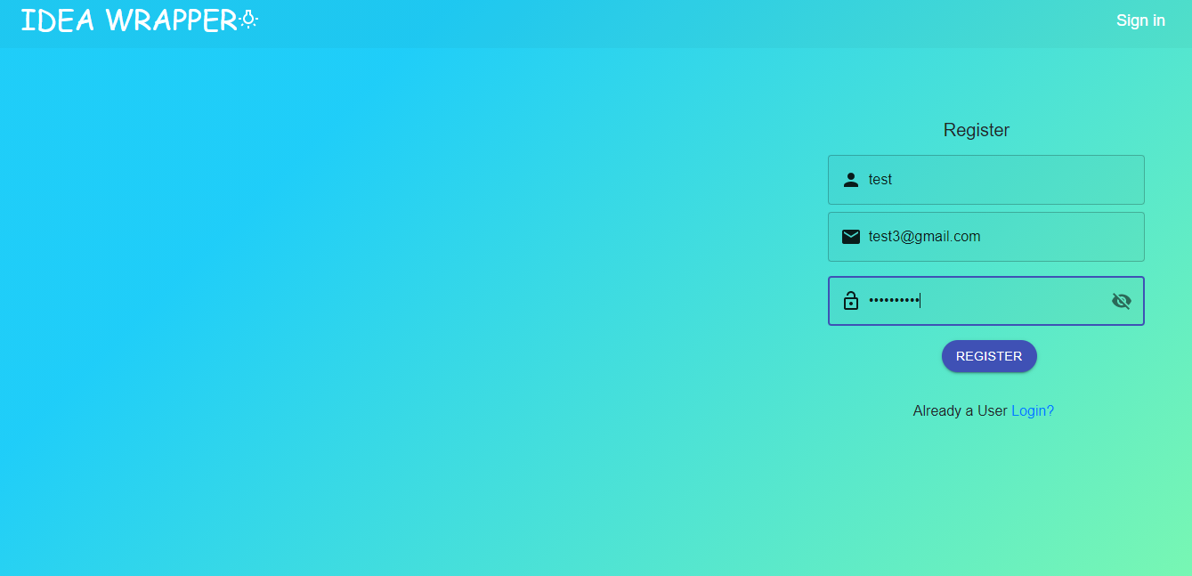

**User Sign Up**

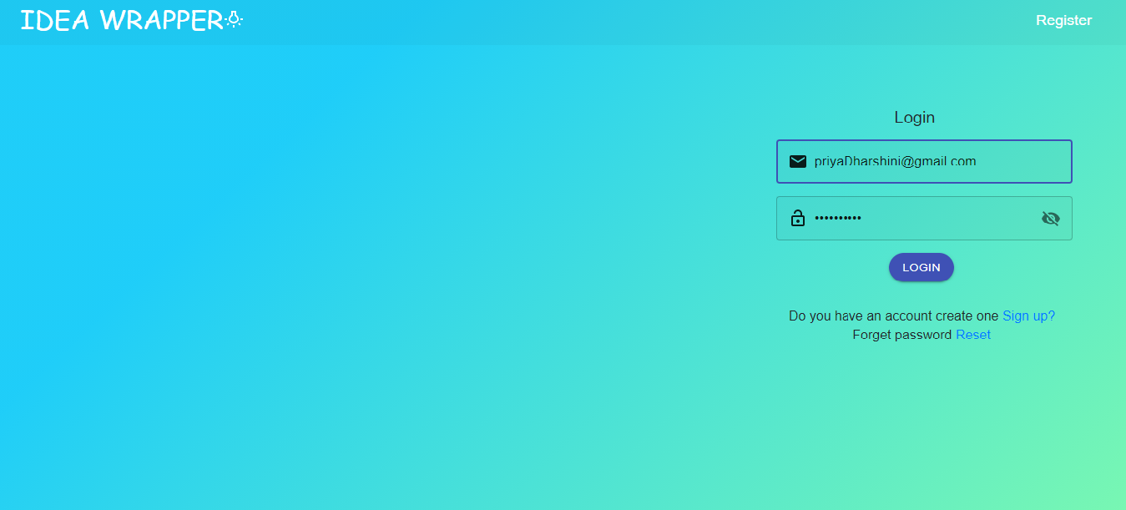

**User login page**

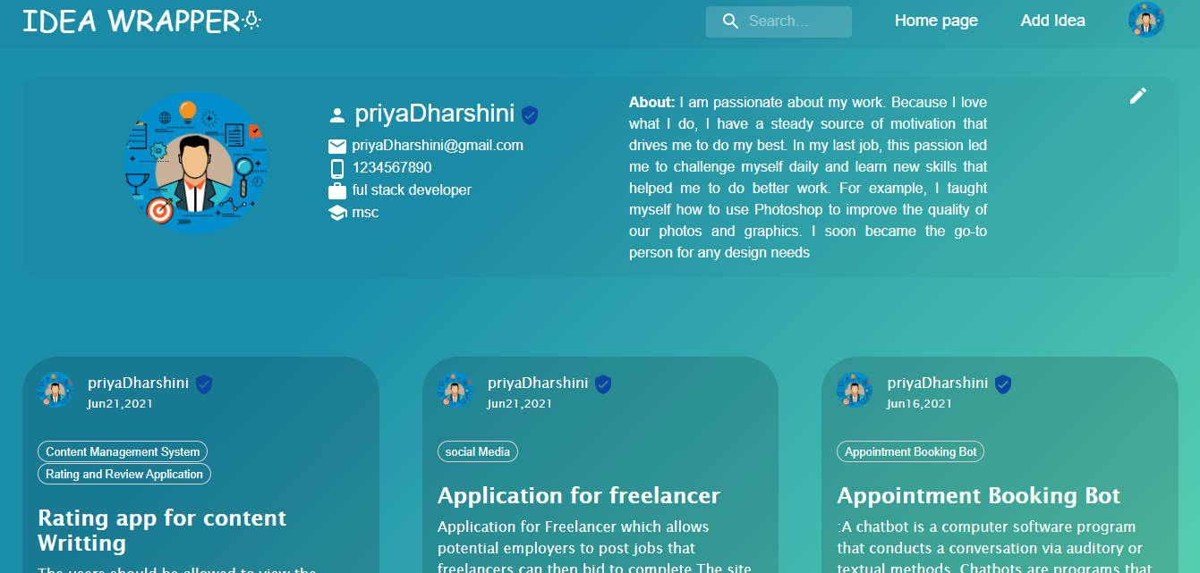

**User Profile page**

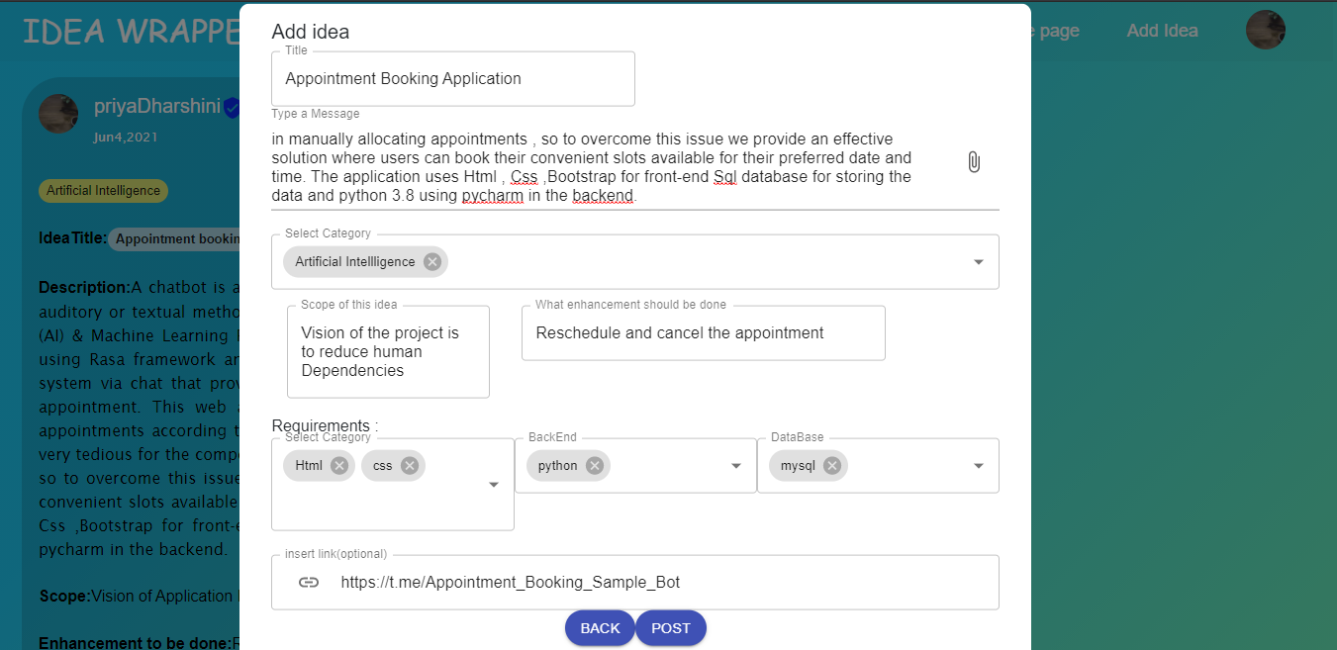

**USer - Add Post**

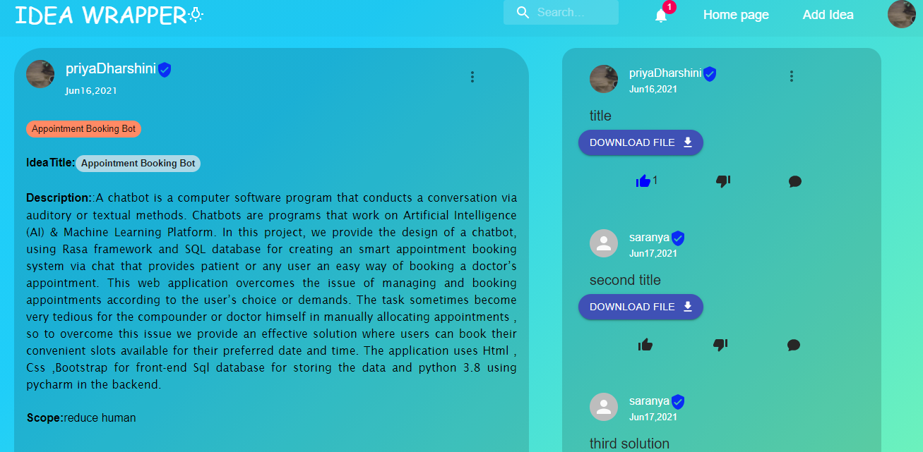

**User Post Detailed View**

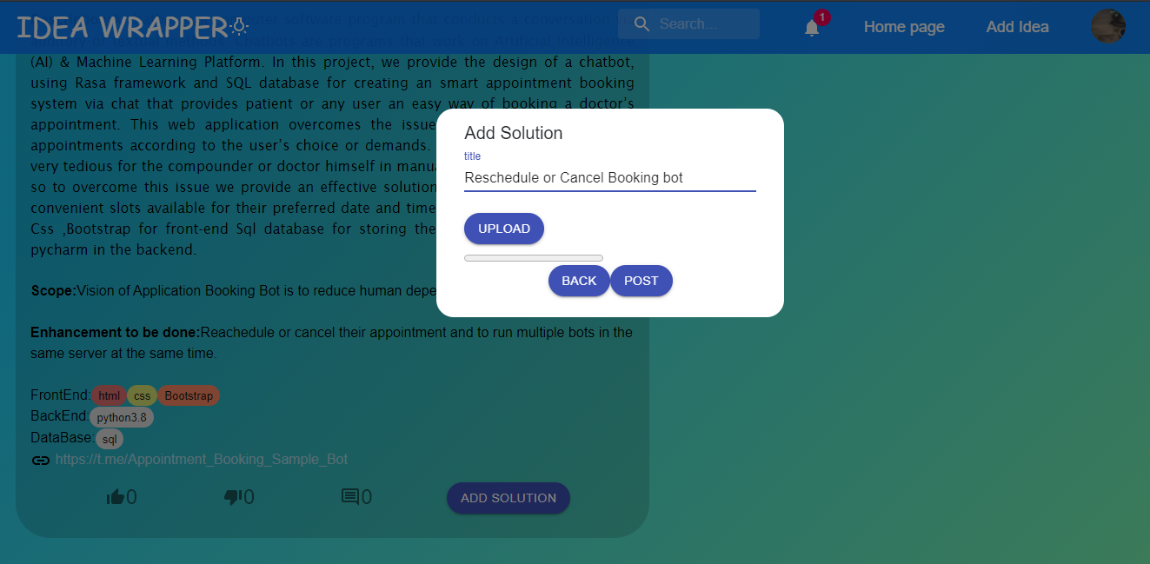

**User-Add Solution**

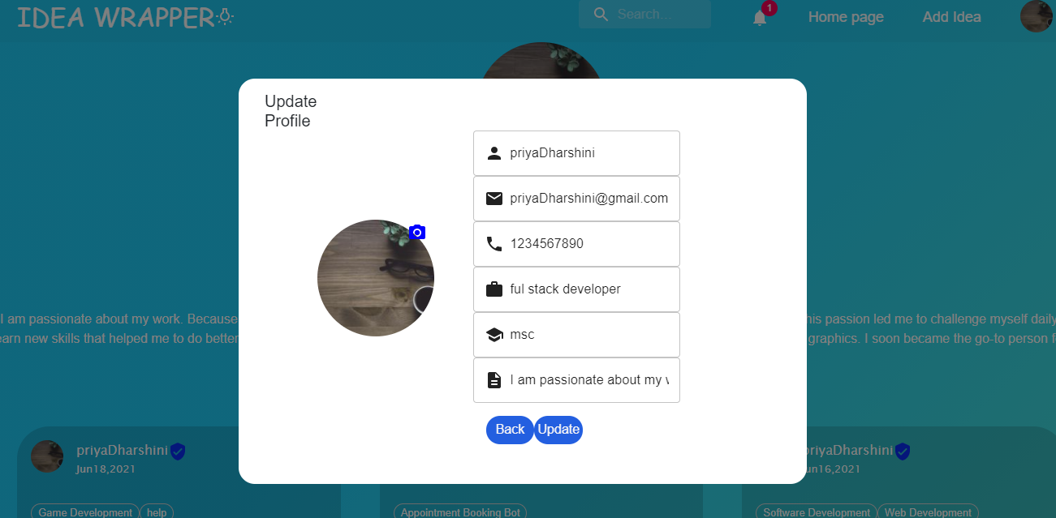

**User-Update Profile**

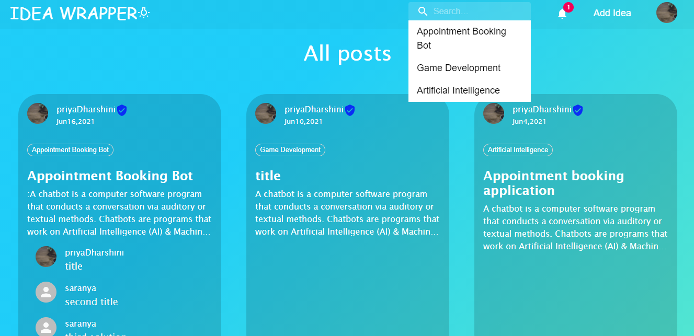**User-Search By Category**

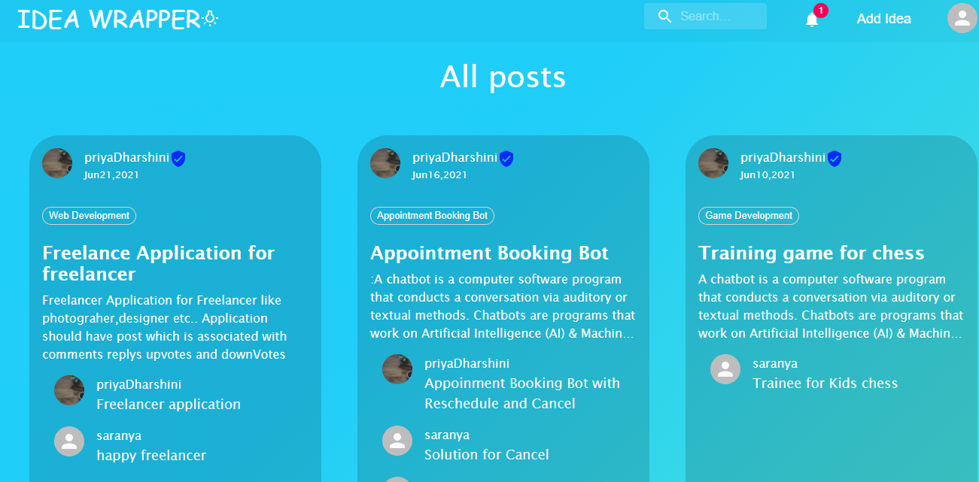

**User-View All Posts**

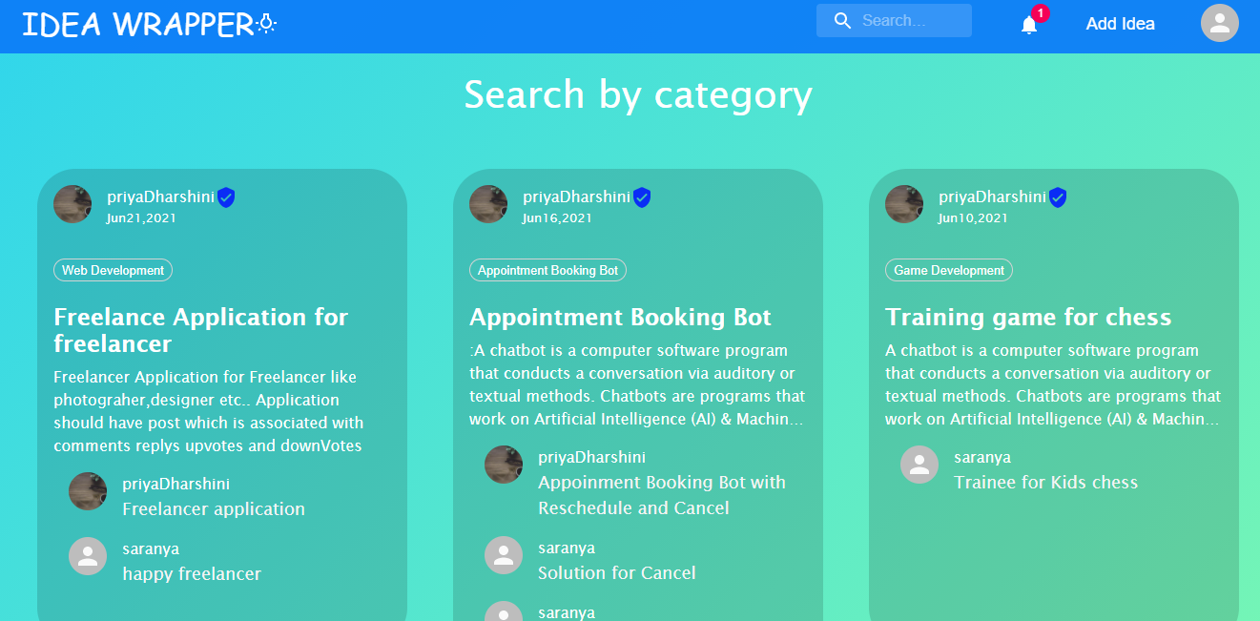

**Search by category**

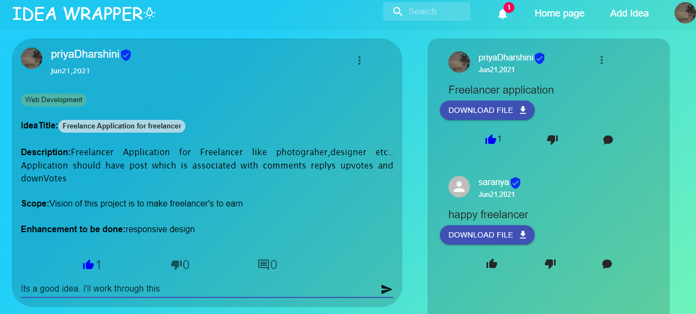

**User-AddComments**

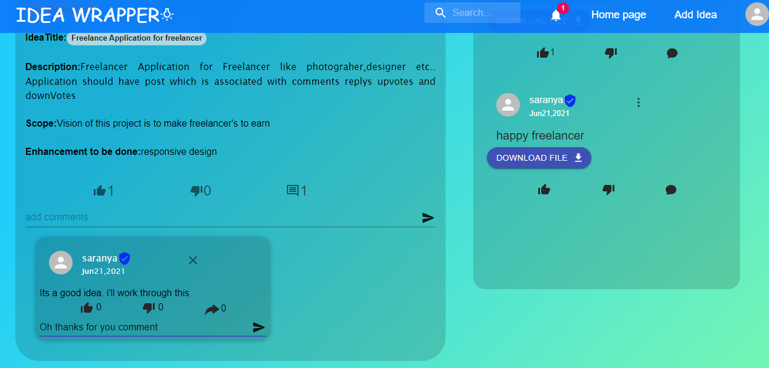

**User-Add Replys**

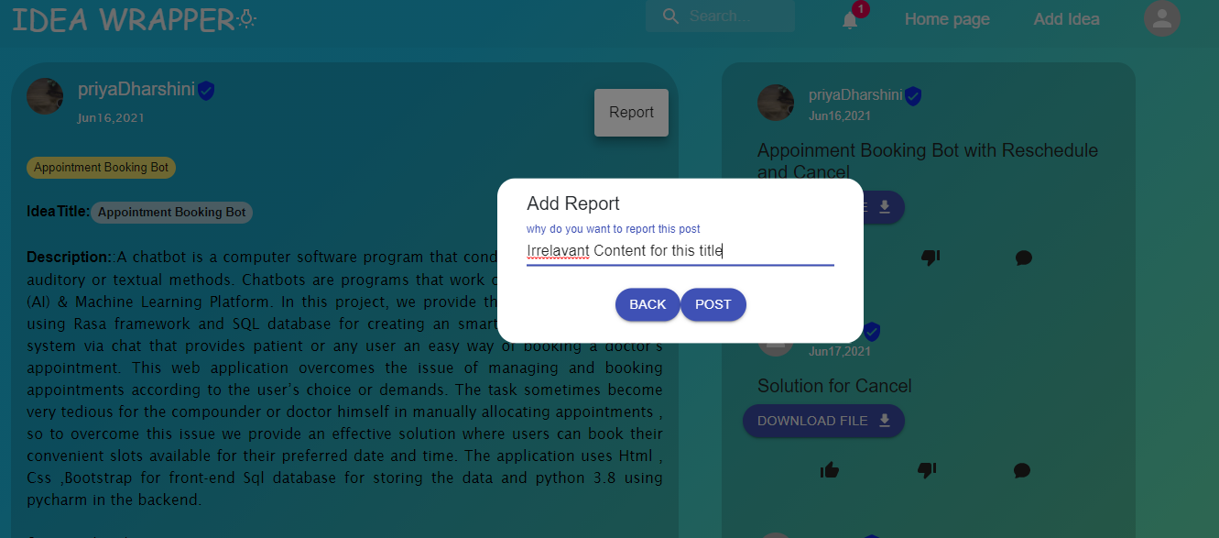

**To report a post**

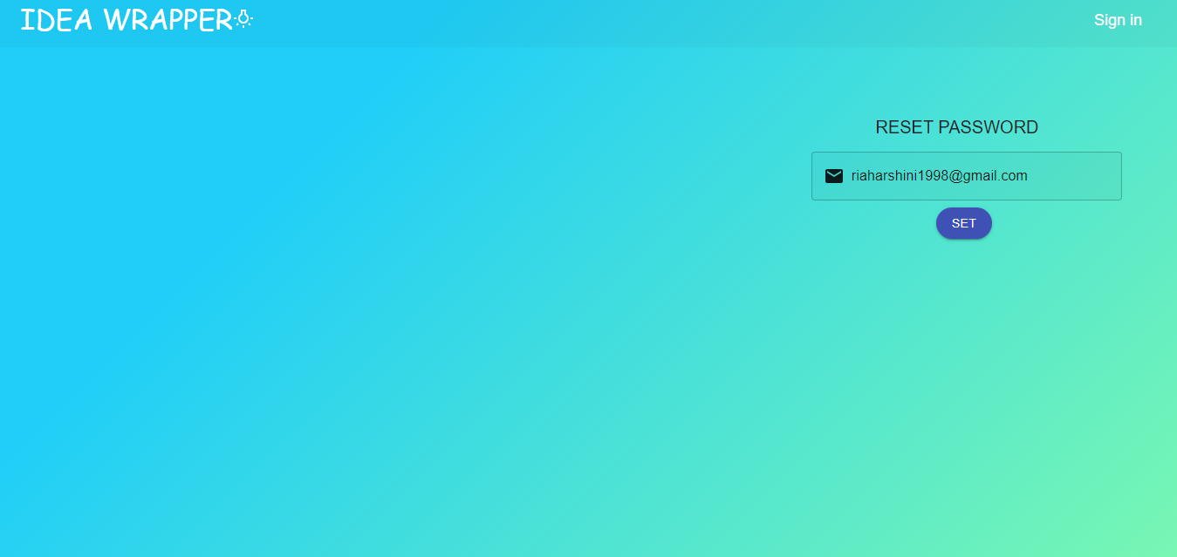

**Forgot password-request for change**

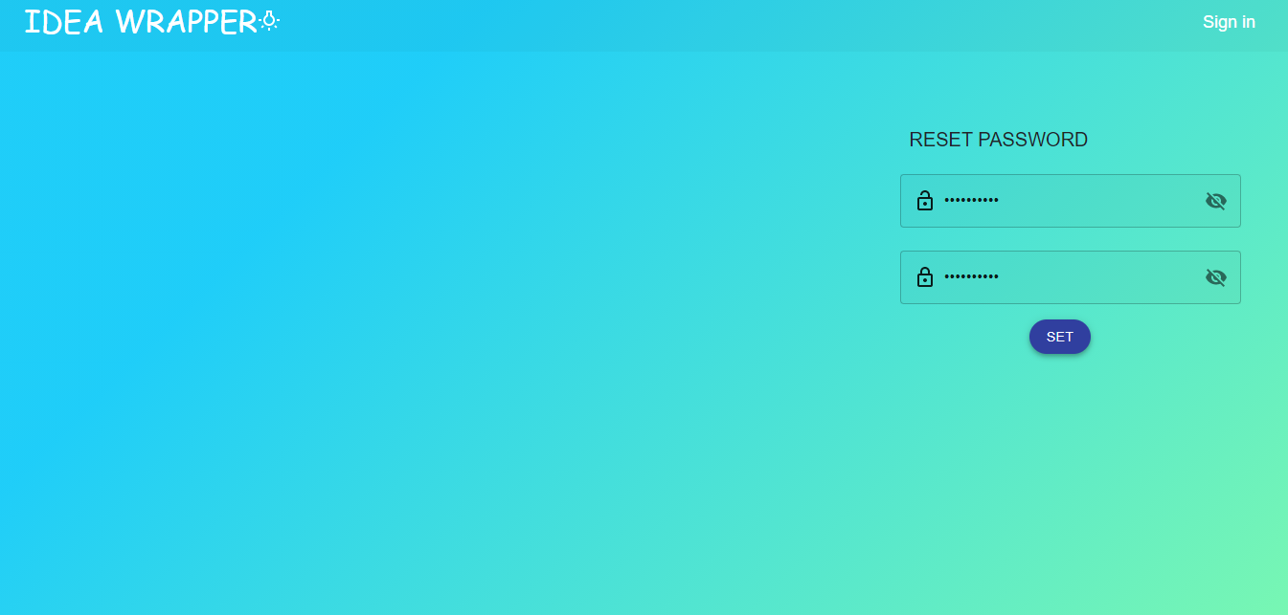

**Change password**

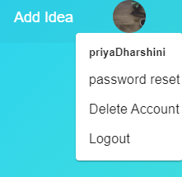

**User-LogOut**

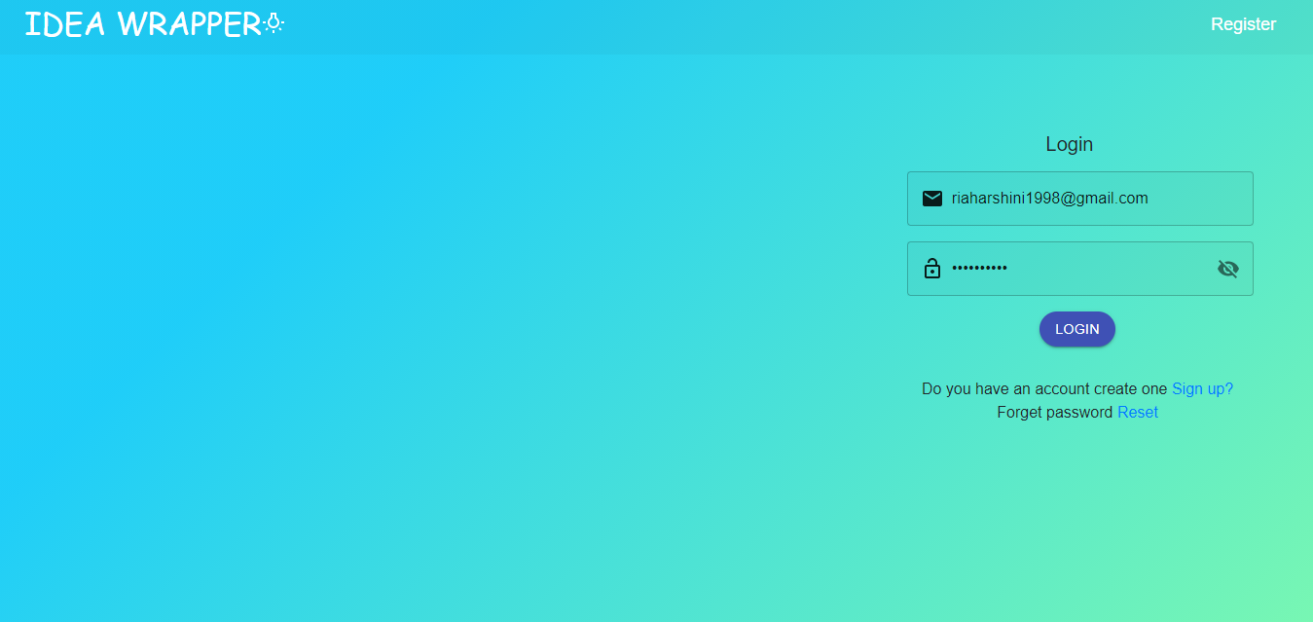

**Admin-login page**

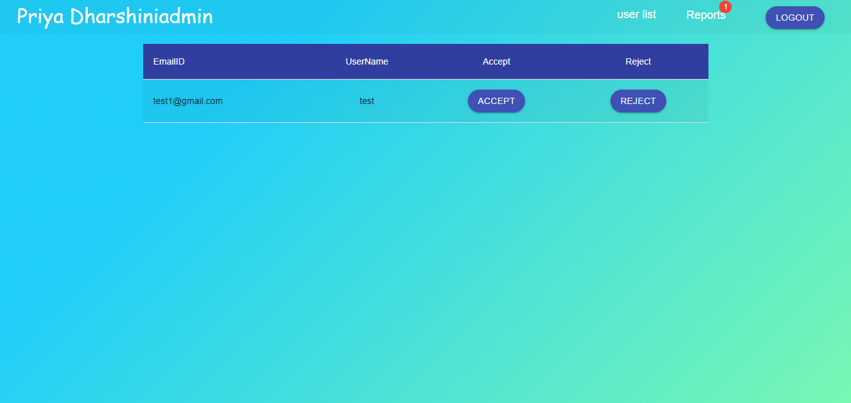

**Admin Dashboard**

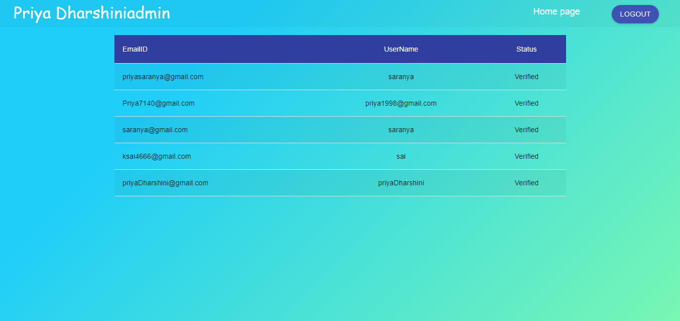

**Admin-userList**

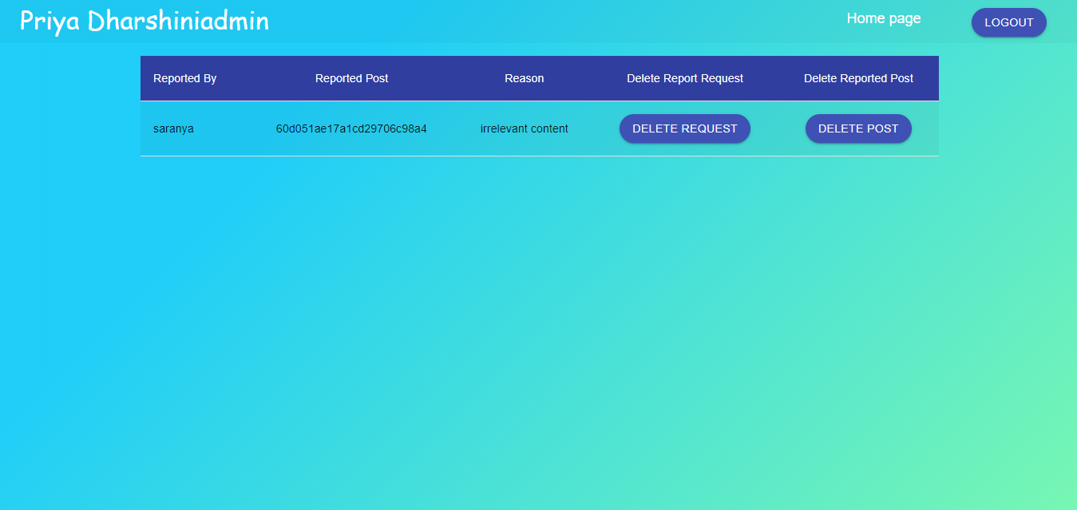

**Admin-Handling Reports**



**Admin logout**

**APPENDIX B : Sample Code**

**Login.js**

import React, { useState } from 'react'

import { Button,FormControl, IconButton, InputAdornment, InputLabel, makeStyles, OutlinedInput, TextField, Tooltip } from '@material-ui/core';

import './Login.css'

import { Link} from 'react-router-dom';

import {useDispatch} from "react-redux";

import Visibility from '@material-ui/icons/Visibility';

import VisibilityOff from '@material-ui/icons/VisibilityOff';

import VpnKeyIcon from '@material-ui/icons/VpnKey';

import clsx from 'clsx';

import EmailIcon from '@material-ui/icons/Email';

import { fetchUsers } from '../../redux/Actions';

import LockOpenOutlinedIcon from '@material-ui/icons/LockOpenOutlined';

import { validate } from 'react-email-validator';

import { ToastContainer, toast } from 'material-react-toastify';

import 'material-react-toastify/dist/ReactToastify.css';

const useStyles = makeStyles((theme) => ({

root: {

'& > *': {

margin: theme.spacing(1),

width: '25ch',

},

},

root1:{

display: 'flex',

flexDirection: 'row',

alignItems: 'center',

padding:'10px',

marginLeft:'70px',

'& > *': {

alignItems:'center',

margin: theme.spacing(1),

},

width:"100%"

},

margin: {

margin: theme.spacing(1),

},

withoutLabel: {

marginTop: theme.spacing(3),

},

textField: {

width: '25ch',

},

icon:{

// color:"gray"

},

}));

function UserLogin(props) {

const dispatch = useDispatch();

console.log(props);

const classes = useStyles();

const [email, setEmail] = useState('')

const [password,setPassword] = useState('')

const [values, setValues] = React.useState({

showPassword: false,

});

const handleClickShowPassword = () => {

setValues({ ...values, showPassword: !values.showPassword });

};

const handleMouseDownPassword = (event) => {

event.preventDefault();

};

return (<div>

<div className='user-signup'>

<div className='inner-reg'>

<center><h5 style={{marginLeft:"7rem"}}>Login</h5></center>

<center>

<form className={classes.root} autoComplete="on" >

<div>

<TextField id="outlined-basic" placeholder='email' style={{width:"40ch",backgroundColor:"rgba(0, 0,0,0.03)"}} type="email" variant="outlined"

InputProps={{

startAdornment: <InputAdornment position="start"><EmailIcon className={classes.icon}/></InputAdornment>,

}}

onChange={(e)=>setEmail(e.target.value)} />

</div>

<div>

<FormControl className={clsx(classes.margin, classes.textField)} variant="outlined">

<TextField

style={{width:"40ch",marginLeft:"-.5rem",backgroundColor:"rgba(0, 0,0,0.03)"}}

id="outlined-adornment-password"

type={values.showPassword ? 'text' : 'password'}

value={values.password}

placeholder="password"

variant="outlined"

onChange={(e)=>setPassword(e.target.value)}

InputProps={{

startAdornment:<InputAdornment position="start"><LockOpenOutlinedIcon className={classes.icon}/></InputAdornment>,

endAdornment:

<InputAdornment position="end">

<IconButton

aria-label="toggle password visibility"

onClick={handleClickShowPassword}

onMouseDown={handleMouseDownPassword}

edge="end"

>

{values.showPassword ? <Visibility className={classes.icon} /> : <VisibilityOff className={classes.icon}/>}

</IconButton>

</InputAdornment>

}}

labelWidth={70}

/>

</FormControl>

</div>

<center>

<Button variant="contained" color="primary"style={{borderRadius:"40px",marginLeft:"8rem"}} onClick={()=>{

dispatch(fetchUsers(email,password))

}

}>Login</Button>

<ToastContainer position="top-center"

autoClose={2000}

hideProgressBar

newestOnTop={false}

closeOnClick

rtl={false}

pauseOnFocusLoss

draggable

pauseOnHover/>

</center><br/>

</form>

{/* </center> */}

</center>

<center>

<div style={{marginLeft:"8rem"}}>

Do you have an account create one <Link to='/Sign up'>Sign up?</Link> </div>

<div style={{marginLeft:"8rem"}}>

Forget password <Link to='/forgot password'>Reset</Link> </div>

</center>

</div>

</div>

</div>

)

}

export default UserLogin;

**login.css**

.login-cont{

min-height: calc(100vh - calc(4.5rem + 2.5rem));

padding:5rem

}

.login-cont h3{text-align: center;color:#00BAFF}

.login-form{

width: 30rem;

justify-content: center;

margin:2rem 20rem;

padding:2rem;

box-shadow: 0 0 0.5rem rgb(0 0 0 / 16%);

}

.login-inputs{ margin-bottom: 1rem;align-items: center;}

.btn{margin: 0 8rem;}

.btn:hover{

background:linear-gradient(

90deg,

rgba(40, 12, 199, 0.678)0%,

rgb(172, 5, 5)100%

);

}

.alreadyuser{

padding:20px;

margin-left:20px;

width:200px;

color:black;

}

**Home.js**

import React from 'react'

import'../../components/card/PostCard.css'

import CardCom from '../../components/card/CardCom';

import { useSelector} from 'react-redux';

import './Home.css'

import moment from 'moment';

import { Link } from 'react-router-dom';

function Home() {

const Data = useSelector((state)=> state.post.posts)

const D = Data.slice(0, 3)

const data = useSelector((state)=> state.post.LikeSortedPosts)

const week = data.filter((e)=>moment(e.createdAt).week() === moment().week())

console.log(week);

const d= week.slice(0, 3)

console.log(d);

// const c = useSelector((state)=> state.post)

// console.log("category",c)

return (

<>

<div className="home-link"><Link to='/AllPosts' className="link-home" >All posts</Link></div>

<div class="wrapper-home">

{D.map((e)=> <><CardCom a={e}/></>)}

</div>

<div className="home-link"><Link to='/Weekly Top Picks' className="link-home">Weekly Top Picks</Link></div>

<div class="wrapper-home">

{d.map((e)=> <>

<CardCom a={e}/>

</>)}

</div>

<div className="home-link"><Link to='/AllPosts' className="link-home" >Search by category</Link></div>

<div class="wrapper-home">

{D.map((e)=> <><CardCom a={e}/></>)}

</div>

</>

)

}

export default Home

**home.css**

.wrapper-home{

display: grid;

grid-template-columns: repeat(3,1fr);

grid-gap:1rem;

margin:2rem

}

.home-link{

display: flex;

grid-template-columns:99% 1%;

grid-gap:1rem;

margin:1rem;

justify-content: center;

}

.home-link-sub{

display: flex;

grid-template-columns:99% 1%;

grid-gap:1rem;

margin:1rem;

justify-content: center;

}

.link-home{

color:white;

font-family: "lucida Sans";

font-size: 40px;

/* font-family: cursive; */

}

.link-home:hover{

text-decoration: none;

color:white;

}

@media (max-width: 1280px){

.wrapper-home{

display: grid;

grid-gap:1rem;

margin:1rem

}

}

**Profile.js**

import React, { useState } from 'react'

import "./Profile.css"

import Avatar from '@material-ui/core/Avatar';

import { makeStyles } from '@material-ui/core/styles';

import TextField from '@material-ui/core/TextField';

import {Button, Container, FormControl, FormControlLabel, FormLabel, IconButton, Radio, RadioGroup} from '@material-ui/core';

import PhotoCamera from '@material-ui/icons/PhotoCamera';

import CreateRoundedIcon from '@material-ui/icons/CreateRounded';

import {connect, useSelector} from 'react-redux';

import {useLocation} from "react-router-dom";

import Axios from 'axios';

import AuthService from "../../auth/AuthService"

import HomeRoundedIcon from '@material-ui/icons/HomeRounded';

import { useHistory } from "react-router-dom";

import {useDispatch} from 'react-redux'

import {updateUser} from '../../redux/Actions'

const useStyles = makeStyles((theme) => ({

large: {

width: theme.spacing(18),

height: theme.spacing(18),

},

root: {

'& .MuiTextField-root': {

margin: theme.spacing(1),

width: '25ch',

},

alignItems:"center",

},

input: {

display: 'none',

},

camera:{

color:"#E3ABAB",

// alignSelf:"center"

},

}));

function Profile(props) {

const dispatch = useDispatch()

const classes = useStyles();

const [gender, setGender] = useState('');

const [profile_picture, setprofile_picture] =useState('');

const [image, setImage] =useState('');

const [age, setAge] =useState('');

const [phone_number, setphone_number] =useState('');

const [description, setDescription] =useState('');

const history = useHistory();

console.log(history)

const user = useSelector((state)=> state.user.users)

console.log(user);

const handleSubmit = async(age,gender,phone_number,description)=>{

console.log(description ,age);

var formdata = new FormData();

formdata.append("file", image);

formdata.append("cloud_name", "ideawrapper");

formdata.append("upload_preset", "ideahub");

let res = await fetch(

"https://api.cloudinary.com/v1_1/ideawrapper/image/upload",

{

method: "post",

mode: "cors",

body: formdata

}

)

.then(res=>res.json())

.then(data=>{

dispatch(updateUser(user._id,age,gender,phone_number,data.url,description))

})

.catch(err=>{

console.log(err)

})

}

let location = useLocation();

// console.log(location);

const {state} =location;

console.log(state);

return (

<div className="profile" key={user._id}>

<div className="profile__body">

<div className="profile__body__left">

<Avatar alt={user.user_name} src={user.profile_picture} className={classes.large}/>

<input accept="image/*" className={classes.input} onChange={(e)=>setImage(e.target.files[0])} id="icon-button-file" type="file" />

<label htmlFor="icon-button-file">

<IconButton className={classes.camera} aria-label="upload picture" component="span">

<CreateRoundedIcon />

</IconButton>

</label>

{/* <div className="container">

<TextField

label="your skills"

type="text"

onChange={(e)=>setDescription(e.target.value)}

/>

</div> */}

</div>

<form className={classes.root} noValidate autoComplete="off">

<HomeRoundedIcon className="nav-item1" fontSize="large" onClick={()=>history.goBack()}/>

<div>

<TextField

label="userName"

type="text"

value={user.user_name}

variant="outlined"

/><br/>

<TextField

id="outlined-password-input"

label="age"

type="text"

onChange={(e)=>setAge(e.target.value)}

variant="outlined"

/><br/>

<TextField

id="outlined-password-input"

label="gender"

type="text"

onChange={(e)=>setGender(e.target.value)}

variant="outlined"

/>

<br/>

<TextField

id="outlined-password-input"

label="phone number"

type="text"

onChange={(e)=>setphone_number(e.target.value)}

variant="outlined"

/><br/>

<TextField

// id="outlined-password-input"

label="skills"

type="text"

// value={user.password}

onChange={(e)=>setDescription(e.target.value)}

variant="outlined"

// className="container"

/>

</div>

<Button variant="outlined" onClick={()=>handleSubmit(age,gender,phone_number,profile_picture,description)}>save</Button>

<Button variant="outlined">reset</Button>

<div>

</div>

</form>

</div>

<div>

</div>

</div>

// </div>

)

}

export default Profile

**Profile.css**

.profile{

display: grid;

place-items: center;

height: 100vh;

background: linear-gradient(90deg, rgb(231, 172, 172) 0%, rgb(165, 163, 163) 100%);

}

.profile__body{

display: flex;

background-color:rgb(250, 250, 245);

margin-top: 10px;

height: 90vh;

width: 75vw;

box-shadow: -1px 4px 20px -6px rgba(0, 0,0,0.75);

border-radius: 20px;

border:solid rgb(231, 172, 172);

}

.nav-item1{

flex-direction:flex-end;

height: 80px;

padding-left: 2px;

padding-right: 2px;

margin-left: 60%;

color:gray;

margin-top:5%;

}

.profile__body__left{

display: flex;

flex-direction: column;

flex: 0.35;

justify-content: space-between;

padding: 20px;

/* margin-top: -10%; */

border-right: solid lightgray;

/* color: rgb(255, 157, 171); */

}

/* .profile__body__left__icon{

display: flex;

flex-direction: column;

margin-top: -10%;

} */

.camera{

color:#E3ABAB

}

.avatar{

align-self: center;

display: flex;

width: 10px;

size: 10vh 10hh ;

}

.container{

display: flex;

background: linear-gradient(90deg, rgb(231, 172, 172) 0%, rgb(165, 163, 163) 100%);

height:500px;

width: 400px;

border-radius: 20px;

margin-top:48%;

}

.profileImage{

/* color:transparent; */

align-self: center;

margin-bottom: -40%;

}

.profile__body__right{

display: flex;

}

.profile__body__left > h1{

align-self: center;

font-family: cursive;

color: rgb(231, 172, 172) ;

padding: 180px;

margin-top: -6%;

}